PERSONAL PROJECT PROGRESS REPORT – ERD CONTRIBUTION

1. Purpose of Contribution
My main contribution to the Setshabelo Primary School Admission System was the design and development of the Entity Relationship Diagram (ERD). I was responsible for identifying the main entities, attributes, primary keys, foreign keys, relationships, and cardinalities required for the database.

2. ERD Development Process
At the beginning of the project, our ERD contained a large number of entities because we initially considered many possible features for the school system. However, after our meeting with the stakeholder on 16 September 2026, the stakeholder clarified the school’s most important needs and priorities.
Based on this feedback, we removed unnecessary entities and focused the ERD on the core admission requirements. This resulted in a more simplified, organised, and structured database design.
Lecturer consultations also helped us improve the ERD. The feedback helped us understand how to correctly structure relationships, foreign keys, and cardinalities and ensure that the database reflected the actual system requirements.

3. Main ERD Relationships and Cardinalities
- User – Admin: 1:1 relationship. One user account is associated with one admin.

- User – Parent: 1:1 relationship. One user account is associated with one parent.

- Parent – Application: 1:M relationship. One parent can create multiple applications, while each application belongs to one parent.

- Application – Document: 1:M relationship. One application can have multiple supporting documents.

- Application – Comment: 1:M relationship. One application can have multiple comments, while each comment is connected to an application.

- Admin – Application: Represents the application review process, with the application storing the administrator who reviewed it through ReviewedBy.

- Admin – SchoolUpdate: 1:M relationship. One admin can publish multiple school updates.

- Admin – Achievement: 1:M relationship. One admin can publish multiple achievements.

4. Personal Reflection
Working on the ERD helped me understand that database design must be based on the actual needs of the stakeholder, rather than trying to include every possible feature. The stakeholder meeting helped us reduce the scope, while lecturer consultations helped us improve the technical structure of the database.
This process improved my understanding of database modelling, relationships, cardinality, primary keys, and foreign keys, and showed me how stakeholder feedback can directly influence the technical design of a system.

Initial draft: https://lucid.app/lucidchart/19e20cfe-6ca4-4fa3-9584-4964d596249f/edit?invitationId=inv_8ec8413b-bdf1-4b12-8659-dfcab783b550&page=0_0#
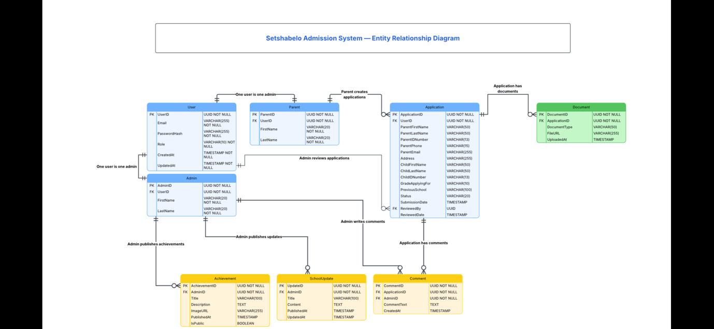
Final diagram:

